Mr Scott Hansen
Director General
Department of Primary Industries
GPO Box 5477
Sydney NSW 2001

June 9, 2019

Concerned Residents
c/o 64 Cove Boulevard
North Arm Cove NSW 2324
Email: mdspack@bigpond.com

Dear Sir

OYSTER LEASE ISSUES – NORTH ARM COVE

We, the undersigned, are residents/property owners in North Arm Cove. We wish to place on record our deep-seated concerns over recent developments in, and the proposed expansion of, farming activities on oyster leases OL86/138 and OL86/140 on the western edge of the North Arm Cove waterway.
We are requesting that, in the public interest, an immediate hold is placed on this activity and that consideration is given to cancelling further lease renewals.
Amenity
There are now 315 houses in our village. Practically every property owner was attracted to this village because of the outstanding natural beauty of this area and the amenity provided by its surrounding waterways.
Which is why every house in the village has been built to face the water.
Many owners purchased in the full knowledge that their neighbours were oyster farmers. They knew that their visual amenity would be impeded by oyster racking, but only for a few hours each day at low tides.
Absolutely no-one here purchased with the expectation that they would ever see the degrading spectacle of an ugly and intrusive network of plastic posts, buoys and baskets floating on the water 24 hours per day, all year round.
Environment
The Commercial Fisheries and Aquaculture Department is the body that oversees the development of the oyster industry in our area. It seems to have notoriously bad history of failing to hold delinquent leaseholders to account.
For years, leaseholders were allowed to ignore their legal obligation to keep their leases in a tidy fashion. We have been witnesses to the unremitting and inevitable degradation of unmaintained structures.
The aftermath is still evident today in the form of debris spread along all the foreshores this way east of Tahlee. The pollution includes Balberook Cove/Brackens Bay and Merriwa Boulevard north, up to and into Bulga Creek.
It is not restricted to the mangroves. Extrapolating this to the whole of Port Stephens – not just stretches adjacent to current oyster leases – would most certainly reveal staggering figures of the amount of material released into the environment. It turns up at the Pindimars, Bundabah, Piggy`s Beach – wherever. Local people are obliged to ignore it because the authorities seem resolutely determined not to address the problem.
We are assured by the Aquaculture authority that there is little evidence that the presence of oyster farms promotes silting of the sea bed. However, the scientific evidence is to the contrary and very long-term residents in our village have witnessed over a 50-year period sanding and silting cycles which fluctuate precisely in accordance with the intensity of farming.
Moreover, the owners of the leases have in the past been obliged to relinquish 10 metres of their holdings on the shore side because severe siltation had made them unviable.
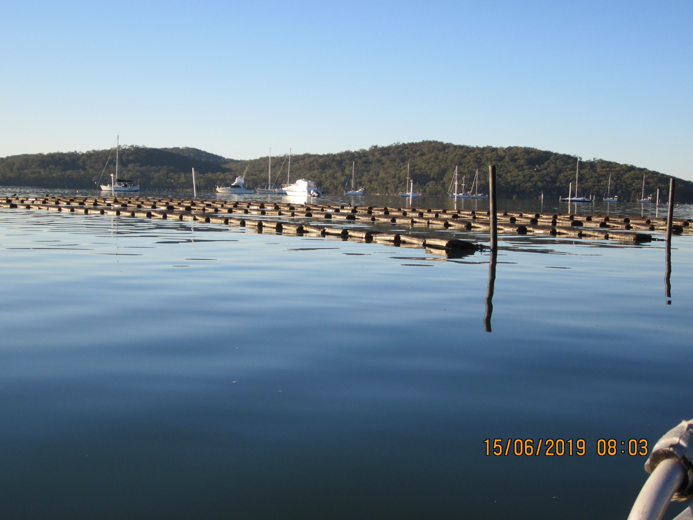
The floating baskets

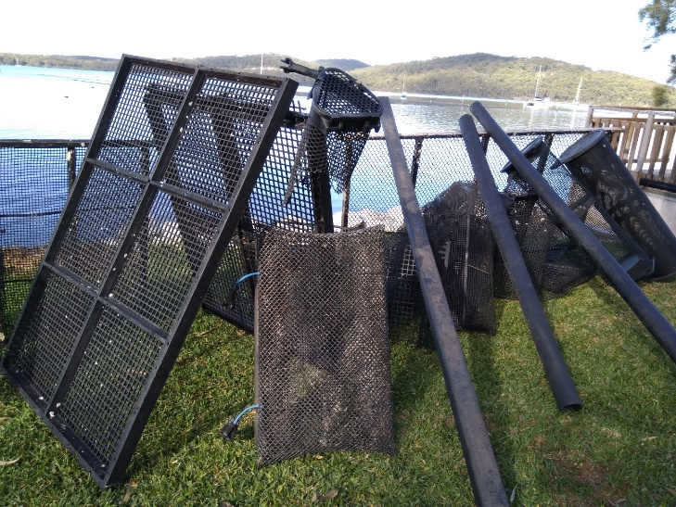
One resident’s efforts in cleaning up the shoreline

Neighbourly relations
We are uncomfortable with the apparent nature of the relationship between the leaseholders and the Aquaculture authority.
For nearly 20 years, these two local leases have not been used for productive purposes other than for a small and failed attempt at farming pearl oysters in 2004. No ‘use it or lose it’ impositions were ever placed on the leaseholders.
Now we are suddenly witnessing this intensive burst of fresh activity with the installation of the new floating baskets.
Given that it was blatantly obvious this new infrastructure was going to shock and distress, and in the knowledge that the OL86/140 lease expires on July 6, 2019, we believe that the leaseholders have been encouraged to act quickly before the proverbial ‘shit hits the fan’.
As far as we’re concerned, the Aquaculture authority has again failed, this time in the promotion of its good-neighbourly duties by providing no prior warning of, or explanation to all those in our community likely to be impacted, for this sudden revitalisation and rapid expansion of oyster farming.
Instead, and in response to enquiries from concerned residents, we believe the office has tried to stifle the inevitable reaction by sending out a condescending pro forma document detailing the legal rights of leaseholders. This has only served to make our people angry and united in opposition to the developments.
Industry risk
315+ toilets in 315 unsewered houses.
We wonder why the DPI risks oyster farming in North Arm Cove. Is such a small financial gain worth the huge potential economic loss to the whole industry in Port Stephens?
Rights
Nobody in this petition denies the oyster farmer the right to earn a living by primary production. They are small business people (as are several in our community). They are entitled to respect and a fair go in the manufacture of a clean and healthy food product.
At the same time, small business owners are obliged to be compliant with regulations. But it appears to us that some oyster farmers are prepared to break the rules and that the Aquaculture authority is not prepared to hold them to account.
A review of farming operations in North Arm Cove
As already stated, we are seeking an immediate cessation of the introduction of the new farming process and of future lease renewals. We request:
- A thorough review of farming operations in North Arm Cove.
- A professional assessment of the impact of farming on this highly sensitive local environment (EIS).
- That a representative from our community be invited to participate in this review process so that feedback can be provided to the residents of our village.
- That the DPI considers the true viability of this industry should oyster business owners be forced to clean up any mess they create due to neglect of infrastructure maintenance and in the ongoing processing of their product.
Just as we respect and accept the rights of the leaseholders to conduct their businesses in a legitimate manner, so do we expect respect through equal, fair and reasonable consideration of our rights and concerns as residents in North Arm Cove. Respect only works when reciprocated.

Yours faithfully
Concerned Residents
See ‘Concerned Residents’ signed petition sheets attached

cc.
The Honourable Adam Marshall, Minister for Agriculture and Western New South Wales, Parliament House, Macquarie St, Sydney NSW 2000
The Honourable Matthew Kean MP, Minister for Energy and the Environment, Parliament House,
Macquarie St, Sydney NSW 2000
Ms Kate Washington MP, Port Stephens, 82 Port Stephens St, Raymond Terrace, NSW 2324
Mr Adrian Panuccio, General Manager, MidCoast Council, PO Box 450, Forster, NSW 2428
Mr Wayne Wallis, General Manager, Port Stephens Council, PO Box 42, Raymond Terrace, NSW 2324



